EGG ROULETTE PROBABILITY AND SIMULATION LESSON
Show the Jimmy Fallon video: on YouTube, search for Jimmy Fallon Eggs Cruise…you’ll find it
Ask class in groups to generate questions regarding the video. Share out and make list. Some guiding questions:
  - How likely is it that Tom would lose that quickly?
  - Jimmy says “that never happens” when Tom gets a raw egg on the first attempt. What is the probability Tom gets a raw egg on his first attempt?
  - Given the first raw egg, how likely is it that Jimmy was safe with the next egg?
  - Does either player have an advantage in this game? Would you rather go first or second?
Choose two students to play the game with the fake eggs. Interject with probability questions as the game progresses, if necessary.
CLASS ACTIVITY 1 – Develop probability tree which shows outcomes for 3 eggs chosen. Allow students to work on teams to develop their trees and find probabilities for all possible outcomes after 3 draws. Stress precision in language:
Conditional probability Dependent events Multiplication rule
See page 3 for a completed 3-draw tree. If time permits, extend to a 4th draw. Notice how parts of the tree will “stop” as the game is won.
CLASS ACTIVITY 2 – In this game, who is more likely to win? Or is there no advantage to either player. Allow groups time to debate and share out ideas.
Reach agreement (hopefully) that extending the tree to 12 draws could be a bit cumbersome / time-consuming. We’ll perform a simulation instead to examine the probability of either player winning the game.
To perform the simulation: give teams of students one suit from a deck of cards. Remove the ace, so that 12 cards remain – these cards will represent the 12 eggs in the dozen. The cards 10, jack, queen, king will represent “raw” eggs; the remaining cards are hard-boiled. Shuffle the 12 cards.
Mark off two area to place the cards – the card dealt first will be for Tom’s pile; the next card for Jimmy, and back and forth like the game in the video. Draw cards until one player is dealt two raw eggs. Keep track of the “loser” and how many draws it takes for them to lose the game. A class table can be made to keep track of overall simulation results –
EGG ROULETTE SIMULATION – WHO LOSES?
Draw #  Loser | 3  Tom | 4  Jimmy | 5  Tom | 6  Jimmy | 7  Tom | 8  Jimmy | 9  Tom | 10  Jimmy | 11  Tom | 12  Jimmy

Compute the experimental probability of each player losing egg roulette. Also, this is a great time to start looking at a probability distribution. Think about how we can create a graphical display of the data, and consider its center, shape and spread.
EXTENDED ASSIGNMENT – FOR TEAMS OF 2 OR 3
Groups are given an adaptation of the egg roulette game to explore. For their given game, groups will:
- Develop a probability tree to determine theoretical outcomes
- Graph the theoretical probability distribution
- Perform a simulation of 50 trials for their game
- List and graph the experimental probability distribution
- Compare the experimental results to theoretical
Assign groups one of the following game adaptations to explore:
- 6 total eggs, 3 are raw
- 7 total eggs, 3 are raw
- 7 total eggs, 4 are raw
- 8 total eggs, 3 are raw
- 8 total eggs, 4 are raw
- 8 total eggs, 5 are raw
To complete the simulation, student can assign values to playing cards. Or, the site random.org the “integer set generator” will generate many samples of random numbers which can be used to simulate the game
EGG ROULETTE OUTCOMES FOR 3 ROUNDS: Tom, then Jimmy, then Tom
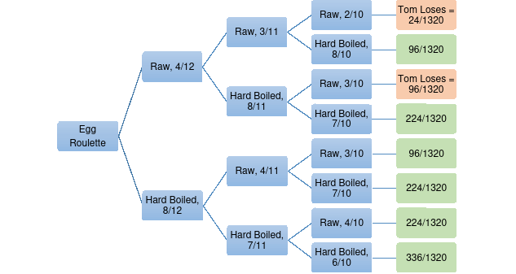
After 3 draws, the theoretical probability of Tom losing is 120/1320 = 9.09%

EGG ROULETTE ASSIGNMENT
With a partner, develop a report which analyzes both the theoretical and experimental probability of egg roulette. Your report should include the following components.
- Develop a probability tree to determine theoretical outcomes (printing this in such a manner where it could be displayed in the room would be appreciated).
- Graph the theoretical probability distribution
- Perform a simulation of 50 trials for the game
- List and graph the experimental probability distribution
- Compare the experimental results to theoretical in a few sentences.
Your group will explore the following game adaptations – circle the one you are assigned:
- 6 total eggs, 3 are raw
- 7 total eggs, 3 are raw
- 7 total eggs, 4 are raw
- 8 total eggs, 3 are raw
- 8 total eggs, 4 are raw
- 8 total eggs, 5 are raw
To complete the simulation, you can assign values to playing cards. Or, on the site random.org the “integer set generator” will generate many samples of random numbers which can be used to simulate the game.

You will be graded on the following aspects of this assignment:
- Precision in calculating theoretical and experimental probabilities
- Effectiveness of graphical displays
- Precision in communication of results

Due date:

Mr. Lochel has HATS 3AC. Please use this time wisely to touch base, ask questions and discuss completed works.

